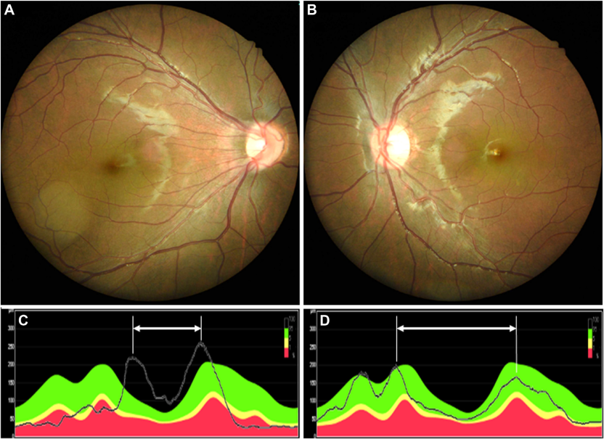

In the right eye, a temporally dragged macula and straightenedblood vessels in the temporal arcade were observed (A), contrasting with the healthier left eye (B). Temporal-superior-nasal-inferiortemporal curves show that peak locations of retinal nerve fiber layer at superior and inferior areas of the right eye (C) are much closerto those of the left eye (D), reflecting the narrowing of the angle between the major vessels.Based on the provided images and clinical description please make an ophthalmic diagnosis for this patient. And output the diagnostic conclusions only.

**Retinopathy of Prematurity (ROP) sequelae (cicatricial stage) in the right eye.**